e-Vaccination System Project Documentation

1. Certificate of Completion
Certificate of Completion
This is to certify that the project titled “e-Vaccination System” has been successfully completed
Project Team Members:
- Sameed – Student1634542
- Affan – Student1636490
Project Completion Date: 05-Jan-2026
Team Leader Name : Sameed

2. Table of Contents
- Certificate of Completion
- Table of Contents
- Problem Definition
- Customer Requirement Specification
  - Functional Requirements
  - Non-Functional Requirements
- E-R Diagrams
  - Entity Relationship Diagram
  - Database Schema
- Algorithms
  - User Registration Algorithm
  - Vaccine Schedule Generation Algorithm
  - Dashboard Alert Algorithm
- GUI Standards Document
  - Design Principles
  - Color Schemes
  - Typography
- Interface Design Document
  - Screens Overview
- Task Sheet
  - Development Tasks
  - Testing Tasks
- Project Review and Monitoring Report
- Unit Testing Check List
- Final Check List

3. Problem Definition

Current System Analysis:
- Vaccines for infants and children are provided manually through school programs.
- Manual records are prone to errors and missing data.
- No centralized database to track vaccination history.
- Parents are often unaware of missed vaccinations.
- Administrative workload is high and time-consuming.
- Delays in vaccination increase the risk of preventable diseases.

Proposed Solution:
The e-Vaccination System will:
- Enable parents to register infants locally on the system.
- Maintain a digital record of all vaccinations.
- Automatically generate vaccination schedules.
- Alert parents via the system dashboard about upcoming vaccines.
- Reduce administrative workload and improve coverage.

4. Customer Requirement Specification

Functional Requirements
- User Registration (parents/guardians)
- Infant profile creation
- Vaccine schedule generation
- Dashboard alerts for upcoming vaccines
- Admin panel for health officials
- Reporting module (vaccination coverage, missed vaccines)
- Search and filter functionality for records

Non-Functional Requirements
- Usability: Easy-to-use interface for parents and admin.
- Reliability: Accurate local record-keeping.
- Security: Password-protected access to user accounts.
- Performance: Works efficiently on local XAMPP/WAMP server.
- Maintainability: Easy to update database or add vaccines manually.

5. E-R Diagrams

Entity Relationship Diagram (ERD)
Entities:
- User: UserID, Name, Email, Phone
- Child: ChildID, Name, DOB, ParentID
- Vaccine: VaccineID, Name, Description, AgeGroup
- VaccinationRecord: RecordID, ChildID, VaccineID, Date, Status
- DashboardAlert: AlertID, ChildID, Message, DateGenerated
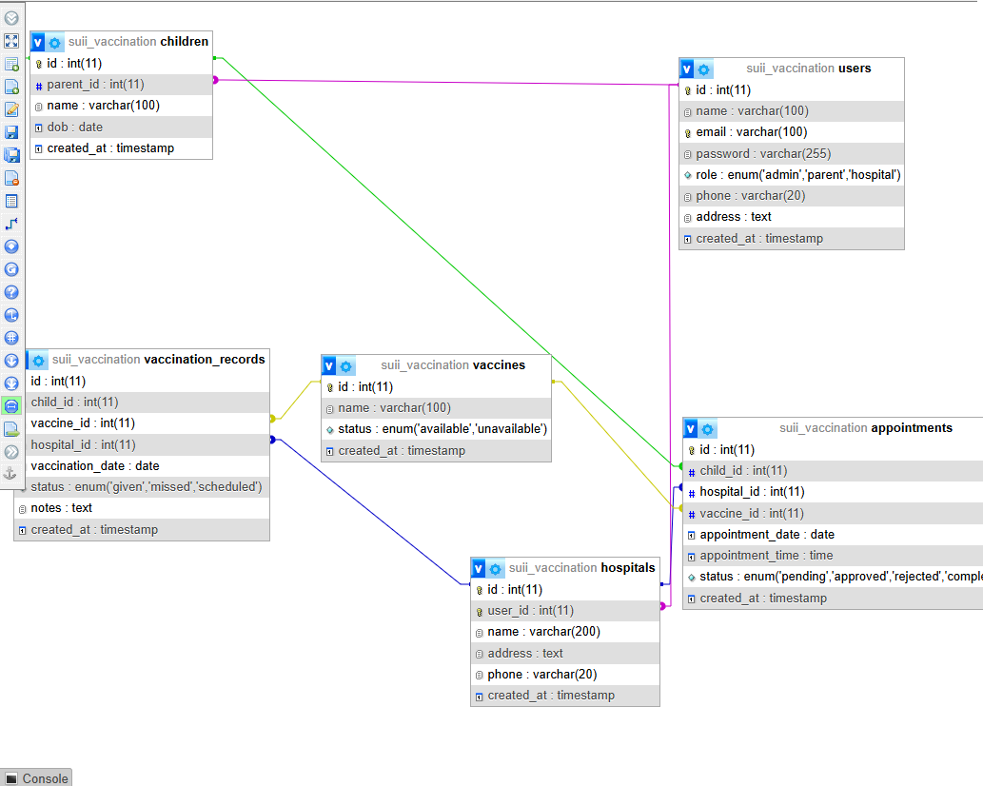

6. Algorithms

User Registration Algorithm
- User enters personal information.
- Validate inputs (email, phone, password).
- Encrypt password.
- Store data in Users table.
- Confirm registration on dashboard.

Vaccine Schedule Generation Algorithm
- Retrieve child’s DOB.
- Match age with vaccine schedule.
- Generate dates for upcoming vaccines.
- Store schedule in VaccinationRecord table.

Dashboard Alert Algorithm
- Check upcoming vaccines within the next 7 days.
- Generate alert message for each child.
- Display alerts in dashboard alert section.
- Update DashboardAlert table with status.

7. GUI Standards Document

Design Principles
- Simple and intuitive interface
- Responsive layout suitable for desktop browsers
- Highlight upcoming vaccines clearly in dashboard

Color Schemes
- Primary: #3498db (Blue)
- Secondary: #2ecc71 (Green)
- Accent: #f1c40f (Yellow)
- Background: #f9f9f9

8. Interface Design Document

Screens Overview
- Login/Signup
- Dashboard (for admin)
- Child profile management
- Vaccine schedule overview
- Dashboard alerts
- Reports & analytics

9. Task Sheet

Development Tasks
Task | Duration | Assigned To
Database Design | 2 days | Sameed& Affan
Backend PHP Modules | 5 days | Sameed
Frontend UI | 3 days | Sameed
Integration & Testing | 3 days | Affan

Testing Tasks
Task | Duration | Assigned To
Unit Testing | 2 days | Affan
System Testing | 2 days | Sameed

10. Project Review and Monitoring Report
- Development Completed: Database, backend PHP modules, and frontend UI completed successfully.
- Testing: All modules tested locally on XAMPP; bugs fixed.
- System Ready: Fully functional on local environment; no deployment needed.

11. Unit Testing Check List
Module | Test Case | Expected Result | Status
User Registration | Valid Input | Success | Pending
User Registration | Duplicate Email | Error | Pending
Login | Correct Credentials | Success | Pending
Login | Wrong Credentials | Error | Pending
Vaccine Schedule | Correct DOB | Correct Schedule | Pending
Dashboard Alert | Upcoming Vaccines Displayed | Success | Pending

12. Final Check List

Pre-Deployment / Local Testing
- Database created and tested on XAMPP
- Frontend UI complete and responsive
- Dashboard alerts working correctly
- Documentation finalized

